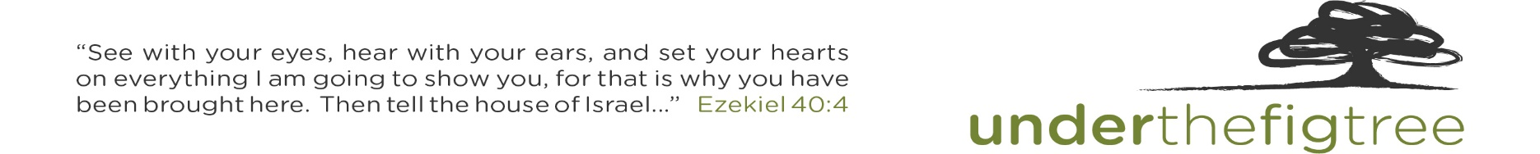
Under The Fig Tree Ministries Presents:
OUT OF EGYPT INTO A GOOD LAND
Egypt-Jordan-Israel Biblical Study Tour with George DeJong
June 07 – June 22, 2024
Friday June 07 lv Chicago Turkish 264 6:00p
Saturday June 08 ar Istanbul 1:30p
lv Istanbul Turkish 505 4:55p ar Cairo 6:25p
Dinner & Overnight Steigenberger Pyramids Hotel – Cairo
Sunday June 09 Cairo/Ancient Memphis – Where Stone Touches Sky
lv Cairo Egypt Air 068 5:30p ar Luxor 6:35p
Dinner & Overnight Nile Palace Hotel – Luxor
Monday June 10 Luxor/Ancient Thebes – The Making and Shaping of Moses
Dinner & Overnight Nile Palace Hotel – Luxor

Tuesday June 11 The Sinai – And God spoke all these Words!
lv Luxor PAS Air Charter 2:00p ar St. Catherine’s 3:00p
Bedouin Supper & Sinai under the stars Overnight

Wednesday June 12 Entering the Wilderness… with God – The Making and Shaping of a People:
Dinner & Overnight Steigenberger Taba Hotel – Taba

Thursday June 13 Walking With – Not Wandering Around Arava border Crossing
Dinner & Overnight Old Village Resort – Petra

Friday June 14 Petra and the Poverty of Wealth
Dinner & Overnight Ramada Dead Sea Resort – Dead Sea

Saturday June 15 From Moses to Joshua/John to Jesus
Dinner & Overnight Ramada Dead Sea Resort – Dead Sea

Sunday June 16 The Decapolis and Nothing New Under the Sun Sheik Hussein Border Crossing
Dinner & Overnight En Gev – Sea of Galilee

Monday June 17 The Galilee, Where Jesus was Shaped & Shaped
Dinner & Overnight En Gev – Sea of Galilee

Tuesday June 18 He Set His Face to Jerusalem – The Jordan Valley
Dinner & Overnight Olive Tree/Dan Hotel – Jerusalem

Wednesday June 19 The Shephelah & The Gospels
Dinner & Overnight Olive Tree/ Dan Hotel – Jerusalem
Thursday June 20 Jerusalem – it is Finished!
Dinner & Overnight Herod’s Hotel – Tel Aviv
Friday June 21 lv Tel Aviv Turkish 343 7:35a ar Istanbul 8:20a
lv Istanbul Turkish 263 9:40a ar Chicago 2:45p

Tour Pricing: TBD

Includes:
- Economy class air from/to Toronto or Chicago
- High Sierra Hydration Packs with bottled water on tour
- Hotel accommodations as per itinerary
- Daily breakfast and dinner buffet
- Lunches on site
- Bibles and Journals
- Deluxe touring motor coach
- All entrance fees
- Guide/Driver Tips
- Porterage
- Airport arrival and exit fees/taxes

NOTE: Fares are subject to additional fuel surcharges as July be assessed by Turkish Airlines prior to
ticketing.

Insurance:
“Travel Guard” trip insurance is available for purchase and upon request we will provide a brochure explaining
the coverage and rates they offer.

