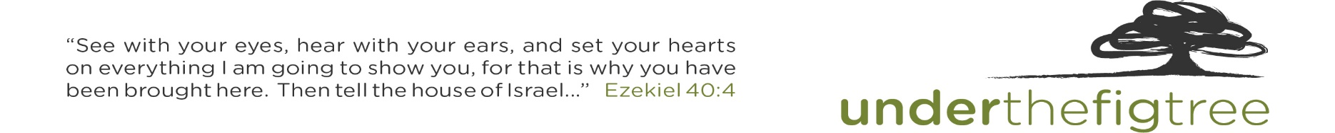
Under The Fig Tree Ministries Presents:
OUT OF EGYPT INTO A GOOD LAND
Egypt-Jordan-Israel Study Tour with George DeJong
July 6 – July 20, 2023

Thursday July 06 lv Vancouver Turkish Air 76 6:00p
Friday July 07 ar Istanbul 3:35p
lv Istanbul Turkish Air 694 6:30p ar Cairo 7:50p
Overnight Steigenberger Pyramids Hotel – Cairo

Saturday July 08 Cairo – Where Stone Touches Sky
lv Cairo Egypt Air 086 6:20p ar Aswan 7:40p
Dinner & Overnight Movenpick Isis Hotel – Aswan

Sunday July 09 Aswan – Meet the gods
Dinner & Overnight Nile Palace Hotel – Luxor

Monday July 10 Luxor/Thebes – The Making and Shaping of Moses
Dinner & Overnight Nile Palace Hotel – Luxor

Tuesday July 11 Mt. Sinai – The Making and Shaping of Moses
lv Luxor PAS Air Charter 11:00a ar Sharm el-Sheikh 12:00p
Bedouin Supper & Sinai Overnight

Wednesday July 12 Descend Sinai – The Making and Shaping of a People
Dinner & Overnight Steigenberger Taba Hotel – Taba

Thursday July 13 Walking With – Not Wandering Around
Taba & Arava border crossing
Dinner & Overnight Old Village Resort - Petra

Friday July 14 Petra and the Poverty of Wealth
Dinner & Overnight Ramada Dead Sea Resort – Dead Sea

Saturday July 15 From Moses to Joshua/John to Jesus
Dinner & Overnight Ramada Dead Sea Resort – Dead Sea

Sunday July 16 The Decapolis and Nothing New Under the Sun
Sheik Hussein Border Crossing
Dinner & Overnight En Gev – Sea of Galilee

Monday July 17 The Galilee: Where Jesus was Shaped
Dinner & Overnight En Gev – Sea of Galilee

Tuesday July 18 He Set His Face to Jerusalem
Dinner & Overnight Dan Hotel – Jerusalem

Wednesday July 19 The Shephelah
Dinner & Overnight Dan Hotel – Jerusalem

Thursday July 20 lv Tel Aviv Turkish Air 865 8:30a ar Istanbul 10:50p
lv Istanbul Turkish Air 75 2:05p ar Vancouver 4:20p

